**How to Login into Brinfo Helpdesk System via email invitation.**

1. Go to URL link <https://helpdesk.brinfoapps.com/>.

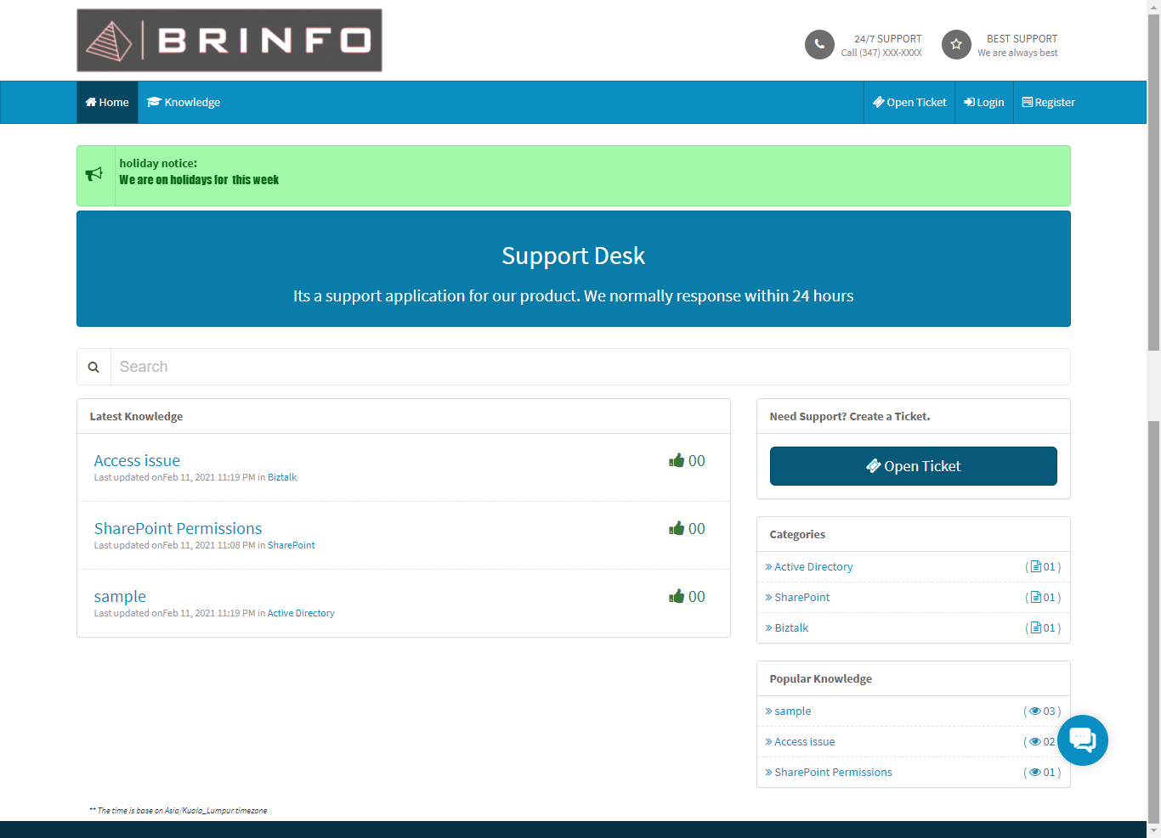

1. If you have been added to the system by an admin, you may receive an email with ID for login as per below:

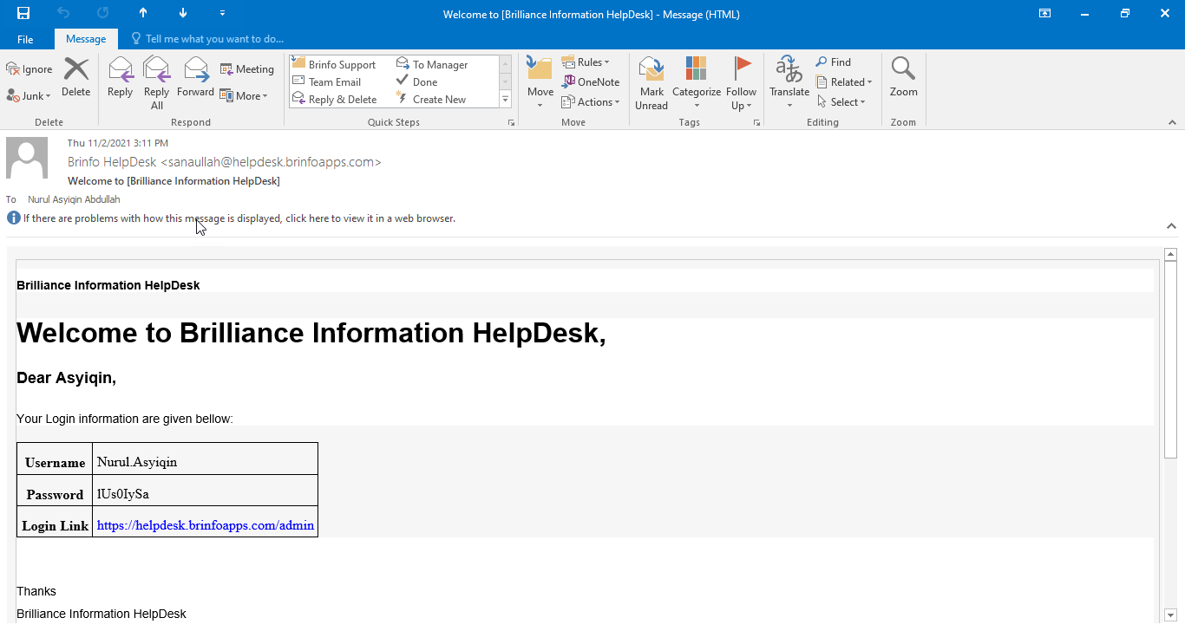

1. Log into the system as per the username & password given.

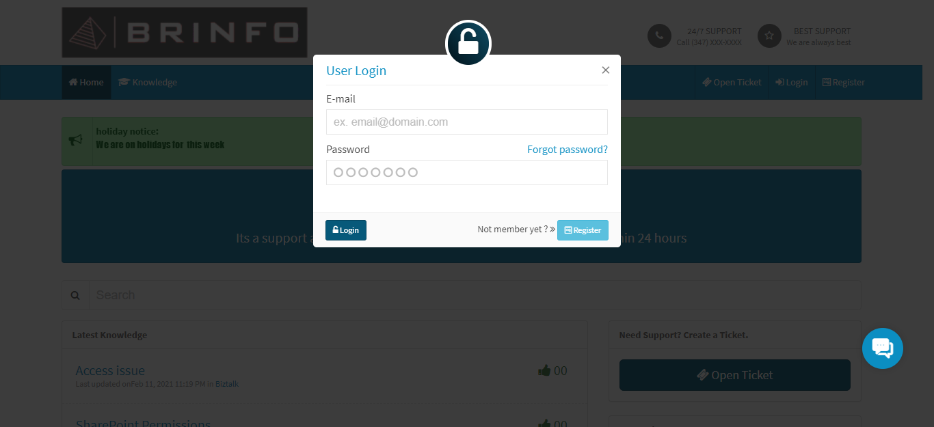

1. You may proceed to change your password in the system.

**How to Login into Brinfo Helpdesk System via registration.**

1. Go to URL link <https://helpdesk.brinfoapps.com/>. Click on Register button on top right of the page.



1. Fill in your details and register to the system.

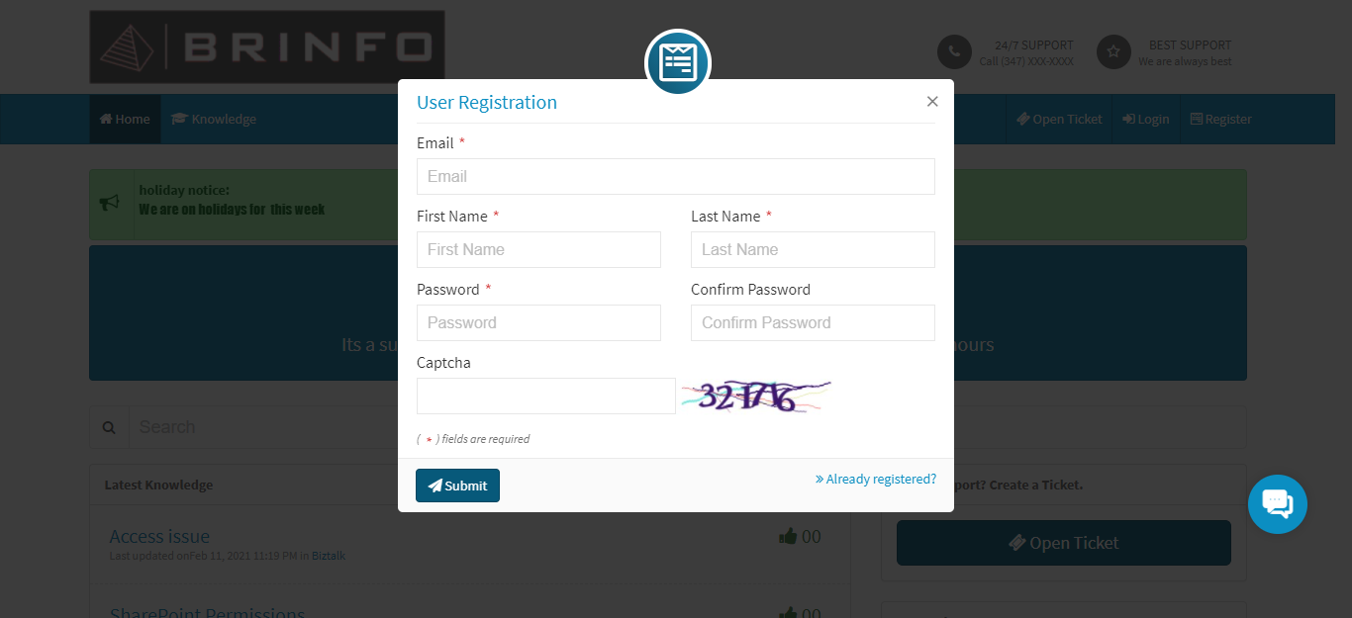

1. You are now registered and may proceed to use the system.